**General Content**

We're not just looking for job seekers. We're looking for dedicated Change Makers ready to make a difference!



We assist job seekers and employers/agencies in finding the appropriate match!

**Follow Us:**

Facebook, Instagram, LinkedIn

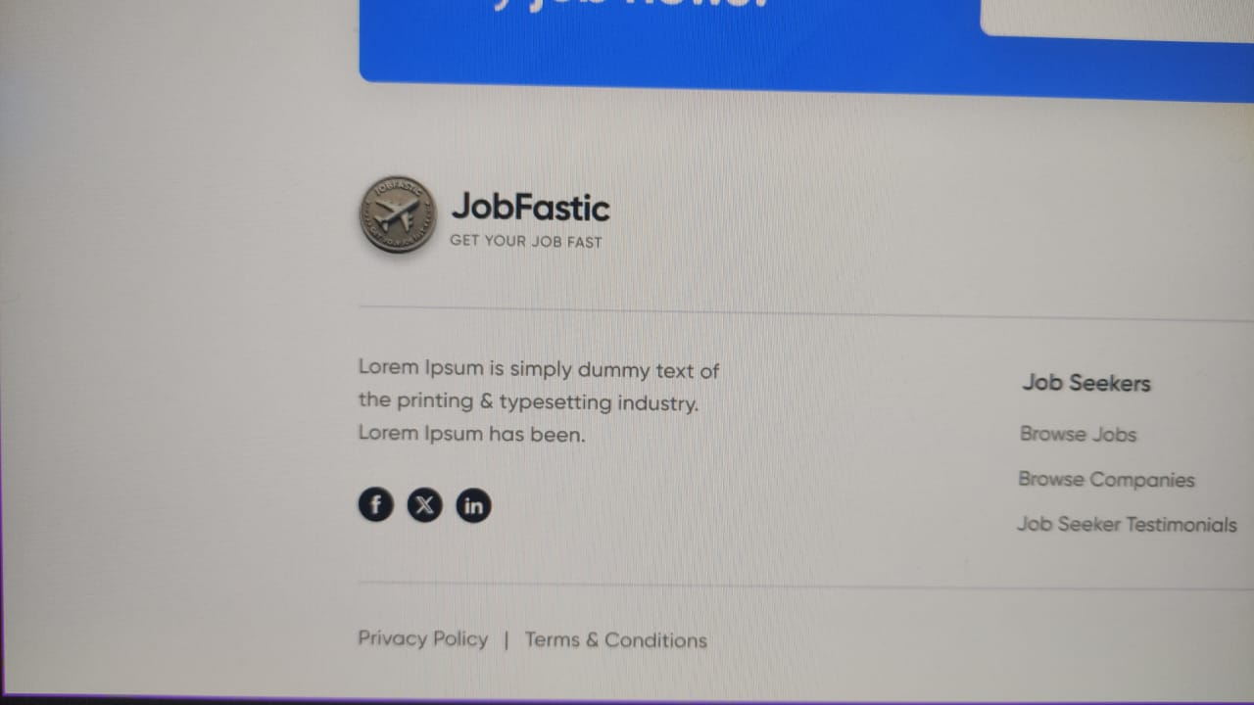

Get Hired in 4 Quick Easy Steps

Follow these simple steps to quickly get hired by leading firms who are looking for skilled laborers like you!

**1. Create an Account**

Get started by creating your profile. Provide your basic information to unlock the doors to countless job opportunities tailored to your expertise.

**2. Upload CV**

Upload your most recent CV, showcasing your skills and experience. This will help employers and recruiters find you faster and match you to relevant job openings.

**3. Search Job**

Use our easy-to-navigate job search feature to explore available positions. Filter and browse jobs that suit your preferences.

**4. Get Job**

Once you've found your ideal role, apply and let us connect you with top employers. Your journey to a fulfilling career starts here—land your next great job with just a few clicks!

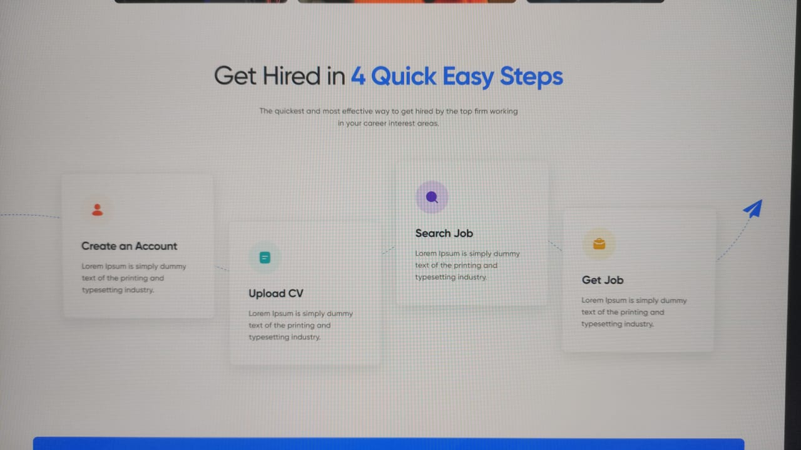

With our all-in-one services, you can connect with top talents in just a few clicks.

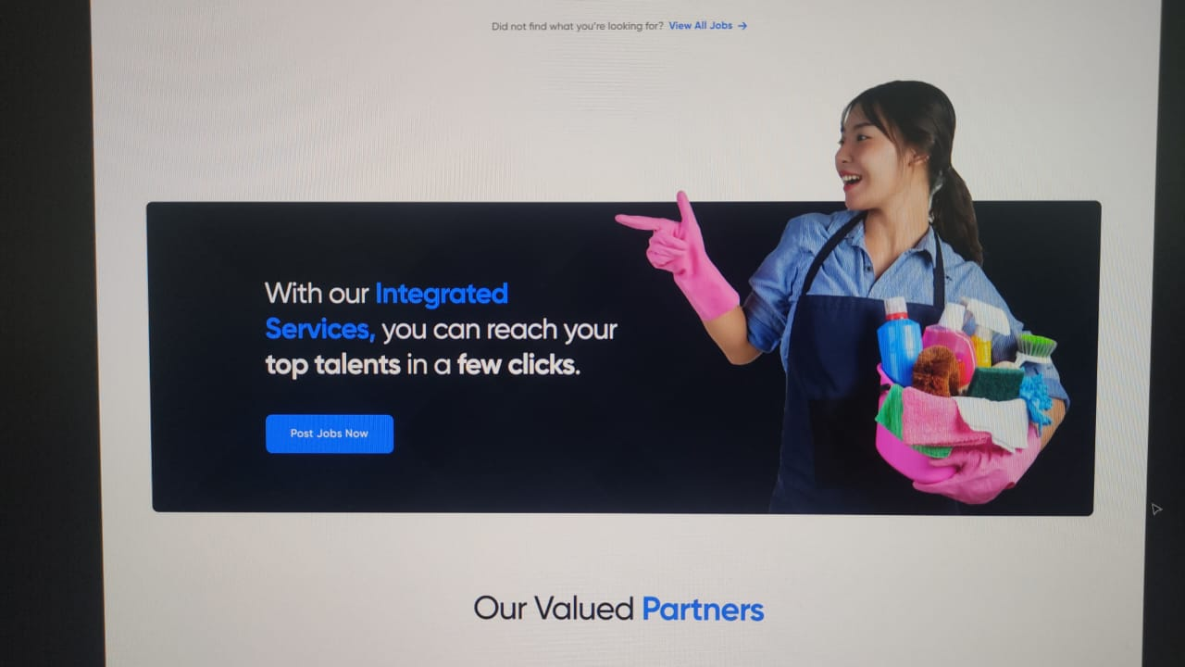

**1. Manage Candidates Easily**

Streamline your recruitment process with tools that allow you to organize, track, and engage with candidates effortlessly.

**2. User-Friendly Platform**

Navigate our intuitive platform, designed for both desktop and mobile, to easily access all the features you need at your fingertips.

**3. Hire the Perfect Candidates**

Find the ideal candidates quickly and efficiently, matching the right talent with the right roles for your business.

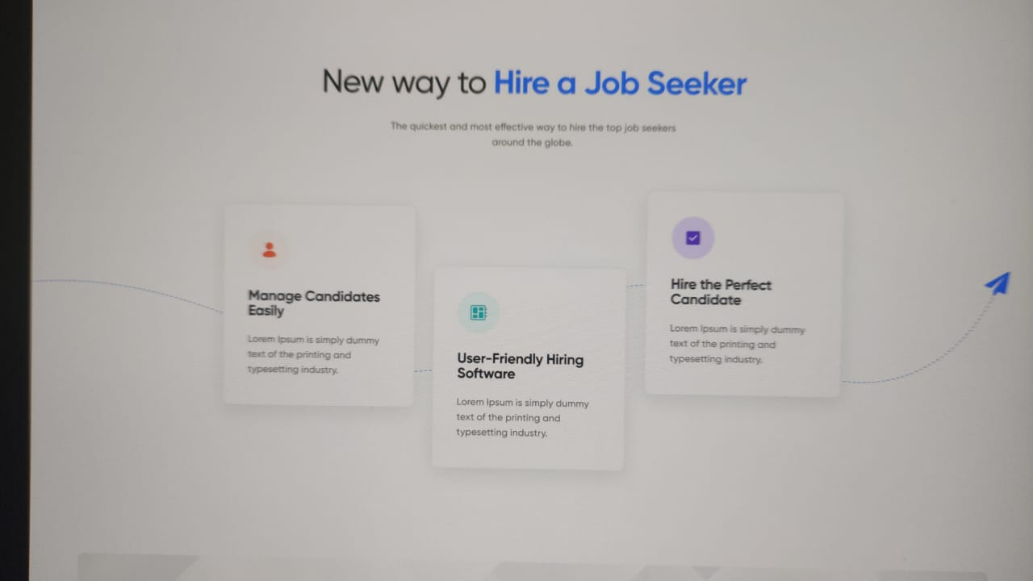

Post, Choose, and Connect

With your ideal job seeker.

Discover candidates that are perfect for you. New profiles added daily!

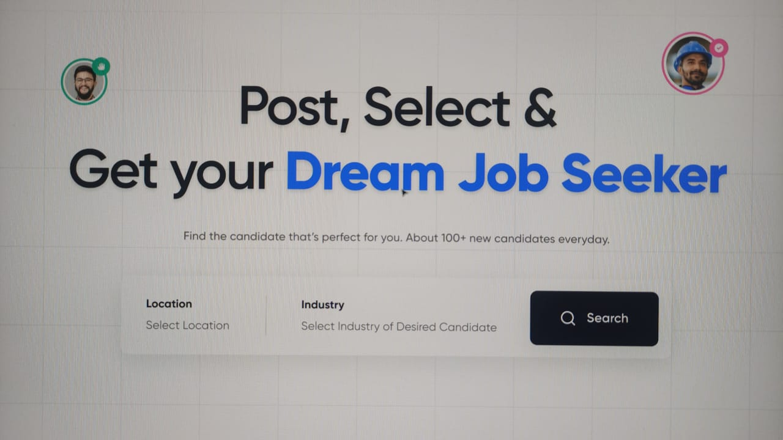

Reviews from individuals who found jobs through JobFastic

Unleash your potential and explore a range of opportunities that match your skills, interests, and career goals.

